Ashley Ferguson
Tasha Candela
Career Field Experience
March 8th, 2017
Masonic Heights Elementary
The dream begins with a teacher who believes in you, who tugs and pushes and leads you to the next plateau, sometimes poking you with a sharp stick called "truth." ~Dan Rather. This quote relates to my placement because as I worked alongside Mrs.Spriet in the second grade classroom I witnessed first-hand all the passion and dedication that a teacher must obtain. With success in mind the students faced reality with a teacher who worked her very hardest to lead the students to be the best that they can be. In my Career Field Experience class, I was required to create weekly blog entries about the tasks I completed during the week, as well as keep a biweekly timesheet of the hours I was working hands on in the classroom. In my opinion Career Field Experience is a unique class because it gave me the ability to connect with teachers who can grant me hands on experience in the classroom, which is something that is not typically done until the third year of a college program. For thirteen weeks, I assisted students with classwork, projects, and group work. I worked one on one with students who needed special attention completing tasks such as studying, reading, and even test taking. I also graded papers and made copies. During times when Mrs. Spriet was ill or had meetings I would direct class well the substitute teacher overlooked my instruction. While reflecting on my overall learning experience in this class, I will outline the three employability skills of responsibility, adaptability, and overall passion, and how I have grown as a professional.
Responsibility and reliability are characteristics that coincide perfectly together. Qualities that lead others to not only believe you but to believe in you. There were many times that Mrs. Spriet had believed in me when no one else did. She encouraged me to do my absolute best well working with the children. I took personal responsibility to conduct the classroom well she was away. As well as maintaining the organization in the classroom by performing tasks the exact same way that Mrs. Spriet would during the day.
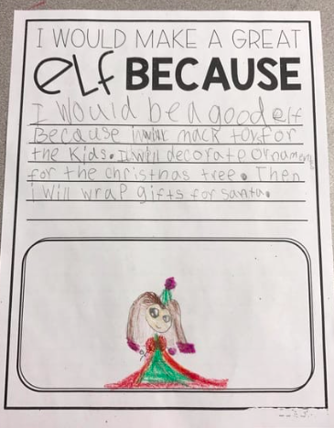
(This is a photo of an assignment that I worked on with the children while Mrs. Spriet was ill)

Passion is another skill that I have developed even greater during the past 13 weeks. Teaching is a profession that is 24 hours 7 days a week, because when you invest in the kids you never stop caring. In my opinion there is no such thing as a bad child. Their spark for desire to learn has just not grown stronger. Passion for teaching is like gasoline for a fire, in order to grow and develop their must be a source. The source being a teacher who cares, one who is willing to devote their life to better the future because it is our children that will one day rule the world. I provided multiple different ways of learning to the children that could not be provided without my help. The teacher to student ratio makes it difficult to establish personal relationships, the kind of relationships that I and abundance of time to form.
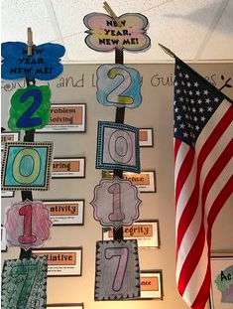
(this is a project that I worked as a team to complete)
“There is no single strategy that works in every classroom, for every teacher, and for each student. However, flipped learning is adaptable to your style, methods, and circumstances” a quote by Jon Bergmann that I have learned to love. Due to the fact that adaptability is such an important skill for all teachers to obtain I have worked hard during the past 13 weeks. I have worked with all types of students from all different backgrounds. It is a key aspect to a successful classroom for the teachers to form a bond with their students. I have developed such strong bonds with these students over the past 13 weeks that they felt comfortable sharing some personal events that have happened in their lives that could have a great effect on the work that they produce. If a student is having difficulty reading for example it may be due to the fact that their parents do not have the money to buy books, or time to enrich their minds with books. Many parents have to work strange long hours and two jobs to be able to feed their children. So, learning becomes a responsibility that is based solely on the attention their receive in the classroom. Making it extremely important for any and all teachers to be adaptable.
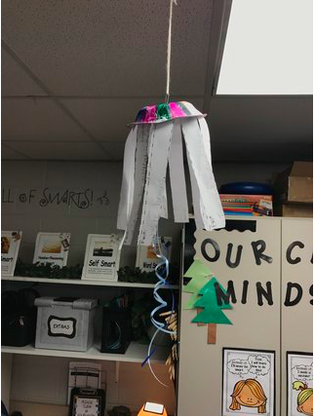
(this is a project I created with a student who was having a very difficult day)
I received an amazing evaluation that I am very proud of, some things I did excellent in are interacting with the students, work initiative and having a professional attitude but I need to improve on a few things including being cooperating by maintaining by maintaining a flexible and positive attitude toward members/colleagues in difficult situations, verbally communicating, documenting task, complete work at the best of my ability, and use logical reasoning to analyze data and make decisions. After reviewing my evaluation, I realized that I have done a great job at Masonic job shadowing and this has been an amazing experience for me.
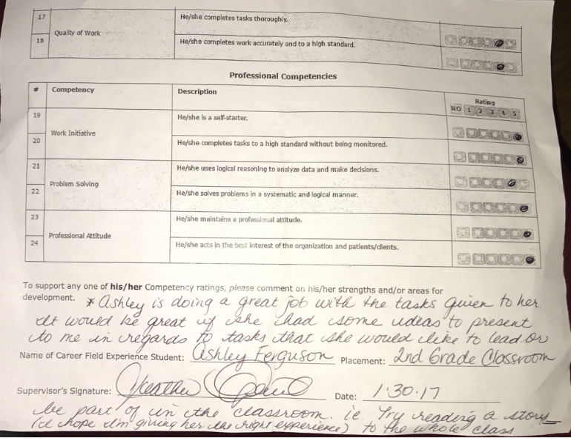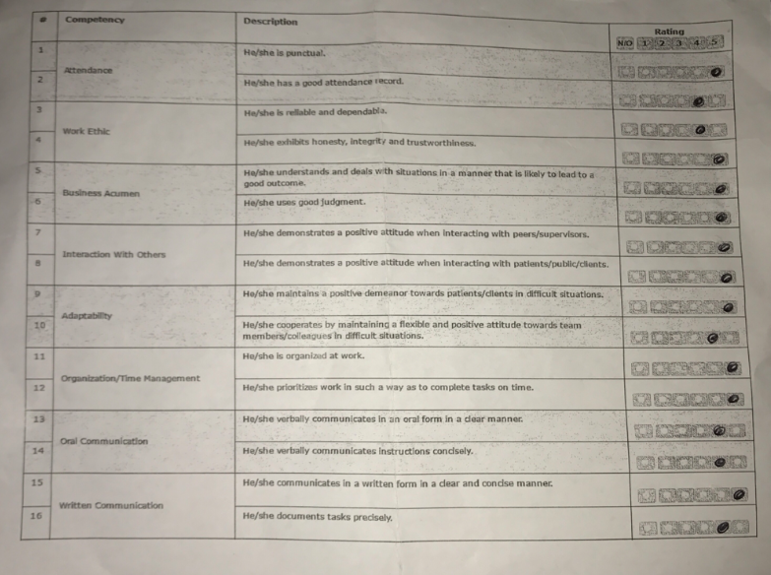
In conclusion, I have developed great professional skills that I would never of had the opportunity to have without this program. This class has helped me grow as a person and develop great connections with staff and students at Masonic Heights Elementary. One of the memories at Masonic that I will never forget is in fact the last day when each student gave me a great big hug and a thank you letter personalized to their favorite memory of us. I would indeed recommend this class to a friend, especially if they were uncertain of the exact profession that they would like to go into. The future holds so many opportunities as I will soon be graduating and continuing my education in early childhood development as well as special education.

